When we first arrived at Chico Mendez we were all a bit nervous because we were soon going to meet our host families. I quickly learned I was grouped with Sally Hartman and my youngest daughter, Emma, which gave me some temporary relief. Both Sally and Emma know some Spanish and I do not. I was going to need their help communicating with our host family who wouldn’t know any English.
Soon Letticia arrived, the matriarch of our host family. When she took one look at our suitcases, she let us know she’d be returning home for a ride to help us transport our luggage to her house. We sat outside to wait. We were expecting Letticia to return in her car only to be surprised when we saw her coming up the road pushing a wheelbarrow! We loaded up our suitcases and took turns pushing them to her house.
When we arrived at the house, we started to learn more about her life in this small Guatemalan village. Once we went through the gate, we saw a big grassy area leading up to the living quarters. This grassy area contained a small corn field, tomato plants, and other vegetables. She had a chicken coop and a pen for a large dog they’d let out at night for protection. Letticia’s family also had two cats to help control the mice and rats. Once we passed through the door of the living quarters, we saw a large outside courtyard with a big sink for washing dishes and washing clothes, a clothesline, and a large area for drying corn. Around the courtyard were several rooms – three bedrooms, a bathroom, and a kitchen. The kitchen did not have a refrigerator. There wasn’t a living room. I thought, “How am I going to stay here?”
Letticia introduced us to her family – her 21 year old daughter, her 19 year old son, and her mother, Lupe, who had long black hair. We didn’t meet her husband that first night. Over the next couple of days the kids would talk about their father but Letticia never did. This was confusing.
One of the first nights, I woke up and saw a small woman with white hair. Who was this woman? At first I thought it may be an intruder and then I thought it could possibly be a spirit. I was trying to make sense of seeing this unexpected woman. We soon learned this was Letticia’s mother-in-law, who was also living in this same residence. No wonder Letticia didn’t acknowledge her! Apparently some things are universal.
As days passed we learned more about the family. Letticia’s husband worked at the house to make money during the day but lived with someone else at night and did not contribute to the household finances or support the children. It was up to Letticia to put food on the table, clothe their kids, and send them to school. The garden and chickens were their primary source of food. There didn’t seem to be a system in place by which she could legally stand up for her rights or the wellbeing of her children. This community had a very limited number of paying jobs. Letticia was fortunate she was able to get a job cooking for a nearby school. She worked during the day, came home at night to cook and care for her family, and then stayed up late to sew clothing to sell. No wonder she was bitter about needing to care for her mother-in-law.
The night before we left, I was sitting at the table with Letticia. She was sewing and I was practicing my Spanish and trying not to cry. I was thinking, “How am I going to leave this place?” Letticia was now my friend and I knew she could use my help. I then noticed Letticia squinting as she was trying to perfect her stitching. We are the same age and I thought about the reading glasses I was wearing. I suggested she take them and give them a try. “I can see!” she said as she smiled broadly. She was not only amazed with how they helped her with sewing but was also amazed I gave her this gift.
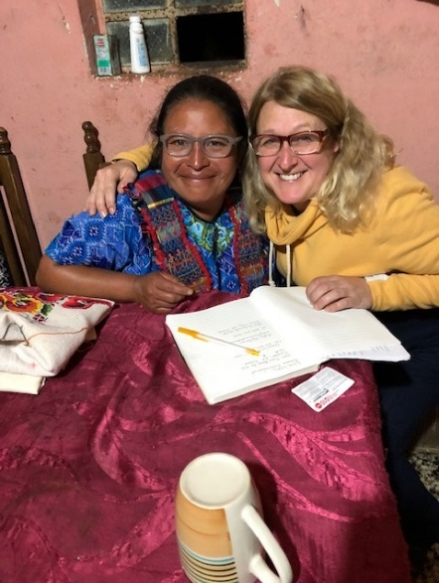

All good stories have a beginning (to set the stage), a middle (the conflict), and an end (at which time the hero or heroine saves the day). We are still writing the end. Families are risking their lives and risking potential separation every day to travel to the United States looking for opportunities for themselves and their children. Letticia was more fortunate than many in her community but we did hear of others who were not so fortunate. The gift of the reading glasses was just one small way to help. By telling Letticia’s story and the stories of other families, I’m hoping to build compassion for their plight. The more stories we tell, the greater the chance we can impact immigration laws and laws protecting women’s rights both here and internationally.

Lisa Lepic

