Going to Guatemala last summer was a great opportunity and privilege for me and everyone else who went. Personally, I gained a lot from the trip. My Spanish speaking improved a lot, I learned about the culture and history of Guatemala, and I was able to help provide service to less fortunate communities. But most importantly, I had fun. While community service, language learning, and hard work are all very important in this trip, the most important part is having an enjoyable experience. I think most people would agree to that, because it’s human nature to want to have fun. No matter the political/economic situation, the Internet connection or lack thereof, it’s human nature to want to amuse ourselves. Even if language and cultural barriers stand in the way, people can and do connect to each other through having fun. If there is no available entertainment around, people will create some.
It’s easy to think entertainment can be hard to come by in the rural areas where we stayed, since there is limited Internet service and these small rural communities are far from the city, and therefore far from movie theaters, stores, and libraries. I’ll admit, I definitely missed my phone’s connection. Despite this semi-isolation, the kids there always found ways to have fun with themselves and with us, the visitors. When visiting a house in San Juan, we played catch with a handmade ball with a couple kids ranging 5-10 years old. There was a language barrier since Spanish is my second language and theirs as well, with their first being the local dialect of Mayan. Even without speaking the same language, it was still surprisingly fun and filled with laughter.
I also had tons of fun teaching my host family how to play Uno and playing with them. I translated for Leah, though my Spanish isn’t perfect and there was still definitely some language confusion. But, even a language barrier can’t stop the fun of people playing games and laughing with each other. Even in the midst of politically and economically unstable times in Guatemala, and a recent volcano eruption, people were doing what they always do - coming up with ways to amuse themselves. In this way people from very different backgrounds can connect even if they don’t share the same culture or language.
I think it’s just human nature to want to be doing something. When there isn’t enough stuff around to keep our mind and/or body busy, we come up with ways to do so, like the aforementioned playing games.
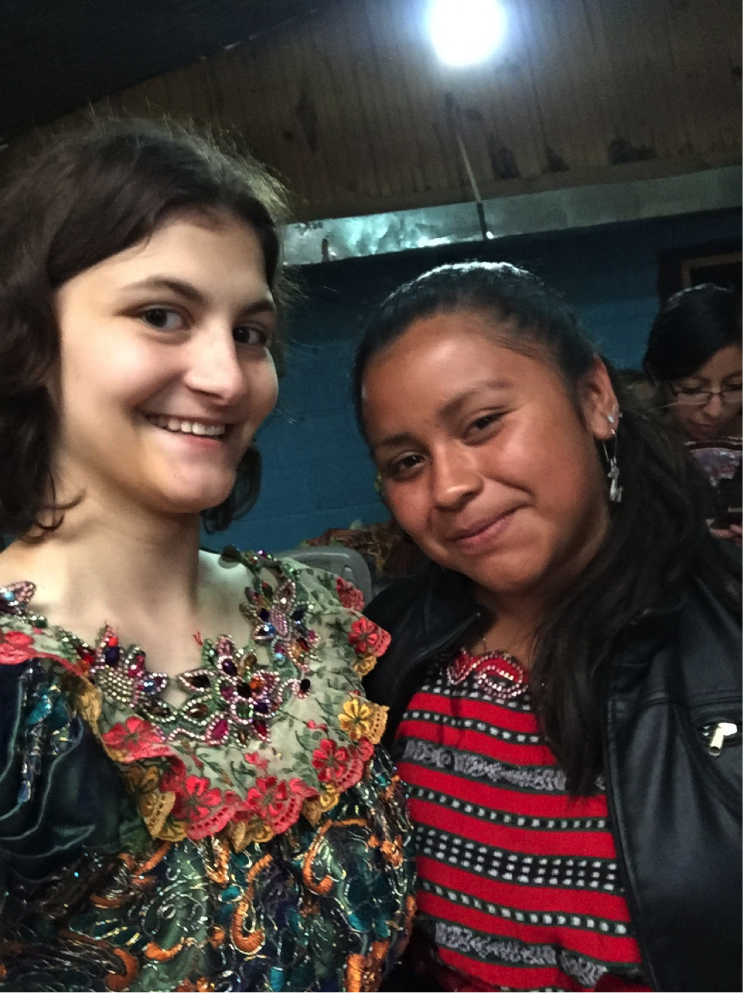
Here in the U.S, it’s really easy to stay busy since we are constantly connected to the Internet, where we have access to almost any sort of entertainment possible. Living near a city with decent transportation, we can easily find things to do like shopping, reading books, or going to the theater to watch a movie. This is convenient, but it has its downsides. We are often over stimulated, and constantly busy because we’re expected to be doing something productive all the time. But in very rural, isolated cities like Pachaj, Guatemala, the case is somewhat the opposite. Due to the geography of these agricultural communities, there is very little Internet service and not many stores or services nearby. So kids, always innovative, come up with games to play based on what they have and through this they can connect with each other and just have fun! And for visitors in the country like us who are immersed in a new culture and language, it’s a perfect way to connect with people. Having fun is one of the most important things on this trip, and it was a huge privilege to be welcomed into a foreign country and home and to simply connect with the people there through having fun.

Justine Reschley

